TUGAS ARSITEKTUR DAN ORGANISASI KOMPUTER

MATERI = ALJABAR BOOLEAN DAN GERBANG LOGIKA

KELOMPOK 1

- SHIFI AMALIA ZEIN

- NABILATUROHMAH

- BILAL

- M. MA’RUFIL KURHI

- ABDULLAH MUBAROK MASPEKE

2. Kombinasi gerbang logika

1. Dua input dimasukkan ke gerbang **AND = (A . B)**

Output dari gerbang **AND** dihubungkan ke gerbang **NOT = ‘(A . B)’**

**2.** Dua input dimasukkan ke gerbang **OR = (A + B)**

Output dari gerbang **OR**  dihubungkan ke gerbang **NOT = (A + B)’**

**3.** Tabel Kebenaran

|  |  |  |  |  |  |
| --- | --- | --- | --- | --- | --- |
| **A** | **B** | **(A . B)** | **(A + B)** | **(A . B)’** | **(A + B)’** |
| 0 | 0 | 0 | 0 | 1 | 1 |
| 0 | 1 | 0 | 1 | 1 | 0 |
| 1 | 0 | 0 | 1 | 1 | 0 |
| 1 | 1 | 1 | 1 | 0 | 0 |

4. **F = (A . B’)**

Input **B** dihubungkan ke gerbang **NOT** untuk mendapatkan **B’**

Input **A** dan **–B** dimasukkan ke gerbang **AND**

**5. F = (A + B’)**

Input **B** dihubungkan ke gerbang **NOT** untuk mendapatkan **B’**

Input **A** dan **B’** dimasukkan ke gerbang **OR**

**6.** Tabel kebenaran

|  |  |  |  |  |
| --- | --- | --- | --- | --- |
| **A** | **B** | **B’** | **A . B’** | **A + B’** |
| 0 | 0 | 1 | 0 | 1 |
| 0 | 1 | 0 | 0 | 0 |
| 1 | 0 | 1 | 1 | 1 |
| 1 | 1 | 0 | 0 | 1 |

3. IMPLEMENTASI FUNGSI BOOLEAN

1. F = (A + B).C

. 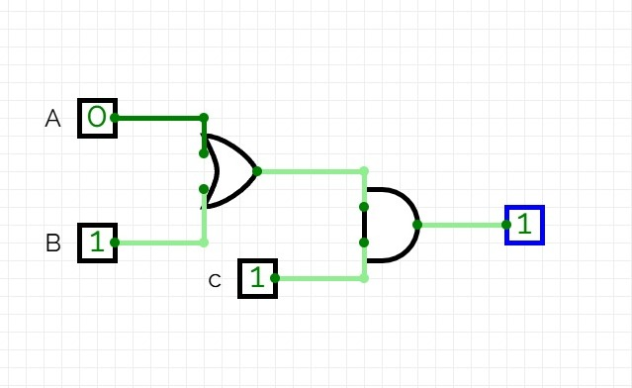

1. F = A.B + B.C + A.C

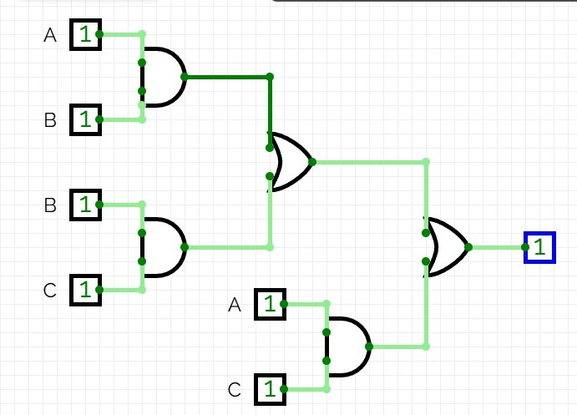

1. Tabel Kebenaran
2. F=(A+B).C

|  |  |  |  |  |
| --- | --- | --- | --- | --- |
| A | B | C | A+B | (A+B).C |
| 0 | 0 | 0 | 0 | 0 |
| 0 | 0 | 1 | 0 | 0 |
| 0 | 1 | 0 | 1 | 0 |
| 0 | 1 | 1 | 1 | 1 |
| 1 | 0 | 0 | 1 | 0 |
| 1 | 0 | 1 | 1 | 1 |
| 1 | 1 | 0 | 1 | 0 |
| 1 | 1 | 1 | 1 | 1 |

1. F = A⋅B+B⋅C+A⋅C

|  |  |  |  |  |  |  |
| --- | --- | --- | --- | --- | --- | --- |
| A | B | C | A.B | B.C | A.C | (A.B)+(B.C)+(A.C) |
| 0 | 0 | 0 | 0 | 0 | 0 | 0 |
| 0 | 0 | 1 | 0 | 0 | 0 | 0 |
| 0 | 1 | 0 | 0 | 0 | 0 | 0 |
| 0 | 1 | 1 | 0 | 1 | 0 | 1 |
| 1 | 0 | 0 | 0 | 0 | 0 | 0 |
| 1 | 0 | 1 | 0 | 0 | 1 | 1 |
| 1 | 1 | 0 | 1 | 0 | 0 | 1 |
| 1 | 1 | 1 | 1 | 1 | 1 | 1 |

4.Penyederhanaan Gerbang logika

1. F = (A+B)’.(A+C)’.(B+C)’

(A’.B’).(A’.C’).(B’.C’)

A’.B’.C’

2.

|  |  |  |  |  |  |  |  |  |  |
| --- | --- | --- | --- | --- | --- | --- | --- | --- | --- |
| **A** | **B** | **C** | **A+B** | **A+C** | **B+C** | **(A+B)’** | **(A+C)’** | **(B+C)’** | **(A+B)’.(A+C)’.(B+C)’** |
| 0 | 0 | 0 | 0 | 0 | 0 | 1 | 1 | 1 | 1 |
| 0 | 0 | 1 | 0 | 1 | 1 | 1 | 0 | 0 | 0 |
| 0 | 1 | 0 | 1 | 0 | 1 | 0 | 1 | 0 | 0 |
| 0 | 1 | 1 | 1 | 0 | 1 | 0 | 1 | 0 | 0 |
| 1 | 0 | 0 | 1 | 1 | 1 | 0 | 0 | 0 | 0 |
| 1 | 0 | 1 | 1 | 1 | 1 | 0 | 0 | 0 | 0 |
| 1 | 1 | 0 | 1 | 1 | 1 | 0 | 0 | 0 | 0 |
| 1 | 1 | 1 | 1 | 1 | 1 | 0 | 0 | 0 | 0 |

|  |
| --- |
| **A’.B’.C’** |
| 1 |
| 0 |
| 0 |
| 0 |
| 0 |
| 0 |
| 0 |
| 0 |

3.

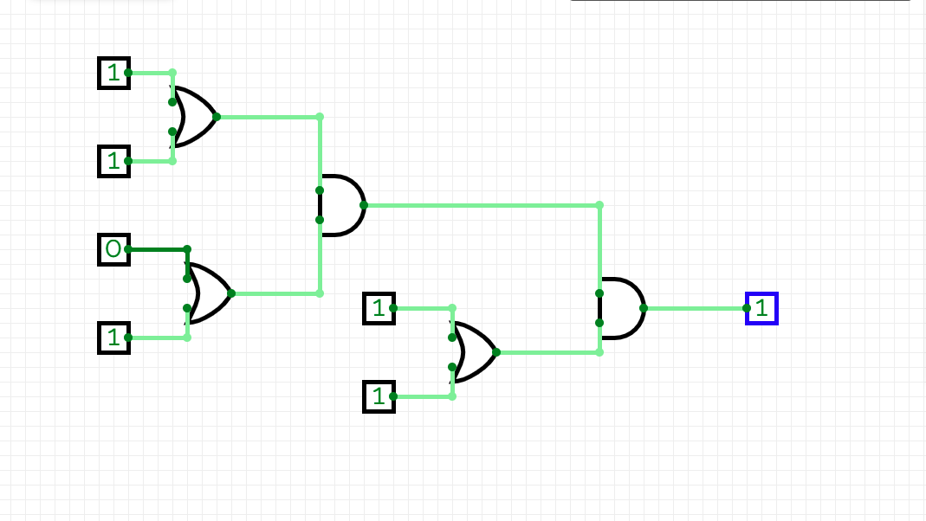

4. 